SAFWAN PETROLEUM TECHNOLOGIES COMPANY
Student Name:
Institution Name:
Date:

Table of Contents
Chapter 1: Background Information 4
1.0 Executive Summary 4
1.1 Company Profile 4
Chapter 2: Description of the Company 5
2.0 History 5
2.1 Recognition and Awards 5
2.2 Commercial Viability 8
2.3 Continuous Investment 9
2.4 Amplified Reach 9
2.5 Company Resources 9
2.6 Company Competitors 10
2.6.1 Kuwait Oil Company 10
2.6.2 Petrobras Company 10
2.6.3 Chevron Company 10
2.6.4 Gazprom Neft Company 11
2.6.5 CPC Company 11
Chapter 3: Mission, Vision, Objectives, and Code of Ethics 11
3.1 Mission 11
3.2 Vision 11
3.3 Objectives 12
3.4 Code of Ethics 12
3.4.1 Respect for others 12
3.4.2 Integrity and honesty 12
3.4.3 Justice 12
3.4.4 Lawfulness 13
3.4.5 Competence and accountability 13
3.4.6 Teamwork 13
Chapter 4: Products and Services 13
4.1 Oil and Gas Services 13
4.2 Oil and Gas Projects 13
4.3 Commercial Services 14
4.4. Fabrication Services 14
4.5 Power Projects 14
Section 5: Safety, Environment, and Health Policy (HSE) 14
5.1 Leadership and responsibility 14
5.2 Legal Compliance 14
5.3 Risk Assessment and Management 14
5.4 Operations and Maintenance 15
5.5 Communications 15
5.6 Relationship with the Community 15
Chapter 6: Compensation Principles 15
6.1 Budget Allocation 15
6.2 Salary Ranges 15
6.3 Salary Audits 15
References 16

Safwan Petroleum Technologies Company

Chapter 1: Background Information

Executive Summary
According to Ramadan and Al-Rashidi (2018), “Safwan Petroleum Technologies Company, commonly identified as SPETCO, is a private corporation well-known worldwide for its impact in reforming the Oil and Gas industry. Safwan, with its main branch located in Kuwait, the company covers countries across the Arab Emirates region (p. 2810)”. Every single project the company undertakes is always completed on time, and it’s the only corporation in the Middle East giving the most extensive services in the upstream and midstream construction and generation of hydrocarbon supplies. Additionally, Safwan is the only company in the Middle East region with a different scope of Petroleum Lab Services, including fluid sampling and onsite fluid analysis. When it comes to financial analysis, the company has an absolute sound financial background with a track record of executing major world-class projects for leading oil companies in the region for the past 25 years.
The company was founded in the year 1963 in Kuwait City, Kuwait. Swafan company started as a trading and contracting company that was engaged in numerous trading activities, which were very successful., Kuwaiti based enterprises founded the company and currently, it has two branches and associated companies. Well-known in Kuwait for its excellent products and services and their fruitful efforts towards revolutionizing the Oil and Gas industry, the company has directed its center on its evolving Early production facility (EPF) proficiency and superior technical knowledge and experience that will enable the expansion of its services in the neighboring regions. Previously working under the Safwan Trading and Contracting company since it was initially founded, the Muslim family-owned corporation is currently realizing the resulting advantages of this earlier divergence approach; accomplishing goods, services, and technological demands of the industry and retail market in Kuwait (Corporate Profile n.d.).

1.1 Company Profile
With more than 35 years of superiority in giving unique, elite resolutions and services, SPETCO is globally distinguished for its contributions in reforming the Oil and Gas industry. The company is steadfastly ranked as a comprehensive service provider with a certified capability to fix complicated predicaments over the value chain from upstream to midstream generation and process specifications, including artificial lift systems, well diagnostics, and power production projects. SPETCO owns a crew of specialists who offers a comprehensive span of composition, process, fabrication, and operational works (Corporate Profile n.d.). The company’s high level of technical know-how and numerous resources have empowered it to the hunt for supremacy in the region. It holds the best and most innovative resources to deliver the most complicated Oil and Gas projects and service deals entirely from the conception stage to maintenance stage.
In reality, SPETCO is distictintively qualified to offer techno-scientific services in the industry. The corporation is pleased of its extraordinary levels of performance. This is driven by the symphonic interconnection of manpower, machines, and methods. This comes from a team of competent employees led by a skilled management team with the full support and backup of safe tools and certified operations for project preparation, control, and administration. These capacities, coupled with its excellent market performance, enable it to successfully undertake any projects. Innovative problem solving is the company’s forte. Its commitment to exceptional quality has resulted in many pioneering accomplishments. The majority of these achievements have been chronicled firsts and stand today as breakthroughs in local petroleum chronicle.

Chapter 2: Description of the Company

History
In 1963, the Safwan company initially started as a trading company under the name “Swafan Trading and Contracting company.” The main aim of the company during its establishment was to cater to the demands of the oil and gas division in Kuwait, but in 1973, the company realized that that the oil and gas sector in Kuwait needed more local service companies. This resulted in the company expanding its scope of services in a perpetual and phased way (Ramadan and Al-Rashidi 2018). The excellence of the Safwan Trading and contracting company holders in acknowledging the growing openings in the local oil and gas field resulted in creating a separate division called Industrial & Energy Services in the early 70’s to specifically service the Oil and Gas sector. Following the rapid increase and more inclusive market demands in the Oil and Gas industry, this resulted in the formation of another different legal entity called Safwan Petroleum Company in 2001. Over the years of operation, SPETCO’s successful completion of its projects led to it being recognized as one of the best Oil and Gas companies providing various aspects of services. For almost decades now, SPETCO has been meeting the goods, services, and technology demands of Kuwait's manufacturing, commercial, and oil and gas quarters. Besides, the company has earned an unbeatable distinction for producing the most satisfactory measures of consumer delivery and service.
According to the current company General Manager, Tarig Gaddumi, “today, the Swafan company services are housed under three distinct divisions specifically; Oil and Gas services, Oil and Gas projects, and commercial sector under which lies our fabrication and miscellaneous services.” Acquiring a status for its amazingly powerful patterns of service delivery over its core mainstays, including EPC, ease of contracts, artificial lift systems, and production facilities- SPETCO is an industry giant that now holds the acumen and width to tackle the most complicated oil and gas projects including after-sales services and support. The company’s capability to sufficiently manage both small and large government projects has enabled the company to maintain a leading position in the Oil and Gas industry (Flaksman et al. 2020). Supported by more than four decades of experienced operation and functioning exclusively in the region, with competent employees, SPETCO remains dedicated to hardening its rank as a corporation with comprehensive solutions.

2.1 Recognition and Awards
Throughout the history the company has been operating, the company has received various awards and recognitions. In 2007, the company received certification (OHSAS 18001) from OHSAS oil and field power services. In 2007, the company received recognition from the chairman of Kuwait Oil Company for the successful completion of an efficient water project. In the same year, 31 January 2007, the company also received another recognition from Kuwait Gulf Oil Company for the company’s positive contribution to the Joint Operation Safety effort. In the same year, 2007, on 9 April, it received another recognition from Kuwait Gulf Oil Company for its positive contribution to the Joint Operation Safety effort. In 2014, it received another honor, KOC Safety Award for the EPF project. In 2015, the company received two ISO certifications, ISO 14001and ISO 9001 certification, after implementing an oil refinement system that conformed to the ISO standards. In 2015, it also received an ASSE GGC HSE Excellence Award and another HSE award in 2016 (Recognition & Awards n.d.)
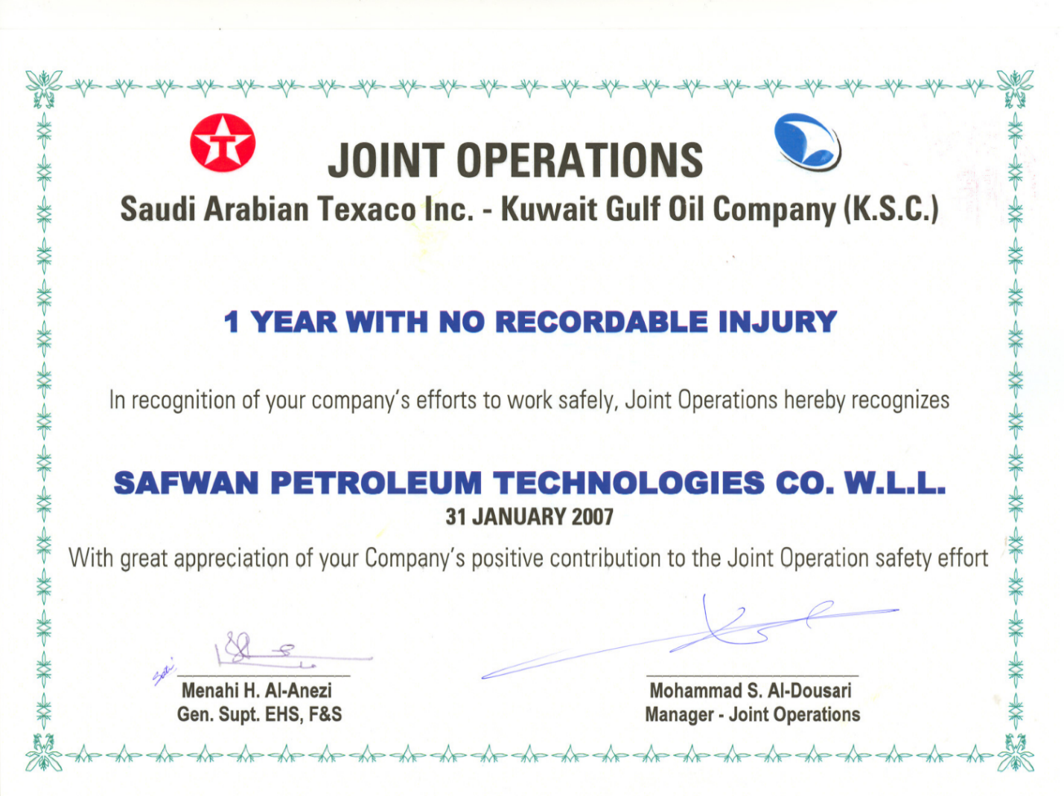
Figure 1: Joint Operations Award (31 January 2007) (Recognition & Awards n.d.)
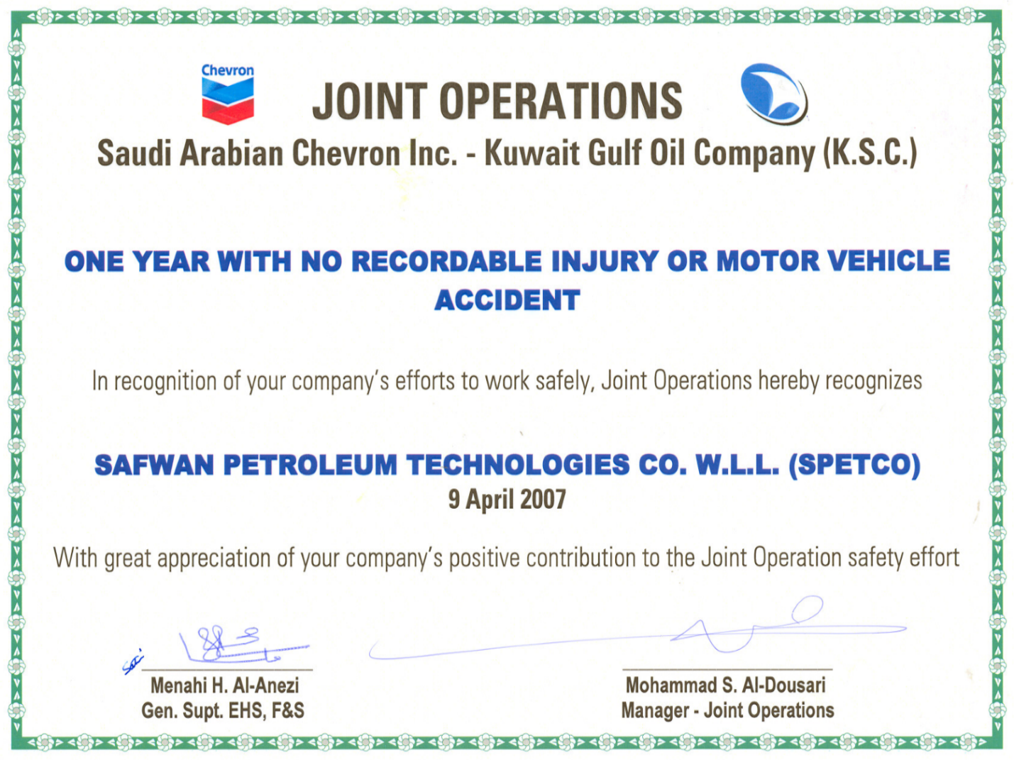
Figure 2: Joint Operations Award (9 April 2007) (Recognition & Awards n.d.)
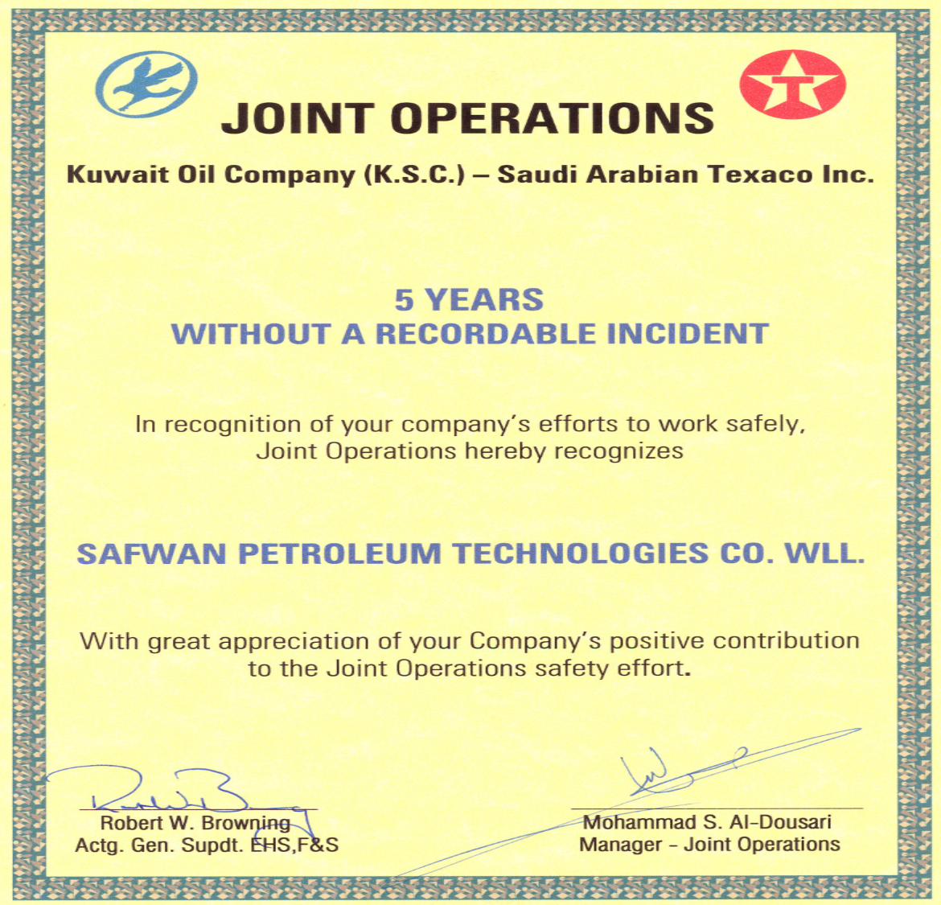
Figure 3: KOC Safety Award (Recognition & Awards n.d.)

2.2 Commercial Viability
With forthcoming Oil and Gas deals hinging on the balance of global oil costs in the future, the company strictly assesses various broader industry shifts to stay one step ahead of their competitors and ensure that their services conform to the latest customer requirements and demands. Dyble (2018) concludes that “being a local company SPETCO is a company that currently operates on a quick decision-making bureaucracy so that their skilled workforce can deliver swift and sound decisions, leading to a more agile turnaround time when handling projects. Furthermore, the company holds local procurement opportunities that also enables it to achieve a faster speed and cost-effective project management strategies”. Opposed to other companies in the Oil and Gas industry, SPETCO has been able to remain competitive because of its ability to deliver projects at lower costs and always prioritizing the health well-being of its employees, vendors, and contractors.
With a workforce of more than 11000 employees, the company’s commitment to ensuring workforce equality has also enabled the employees to remain committed to the company’s projects. Besides being the best employer, the company has always been the best in adopting the latest and most advanced technological tools and solutions. Approximately 45% of the company’s expenses are always spent implementing the most sophisticated technology in their operations. SPETCO commercial viability has always given the company an advantage in bidding for contracts (Dyble 2018). Over the past few years, the company’s unbeatable reputation has spread over the region. As a result, the company has opened two more branches; one in Abu Dhabi and the other in Erbil, Kurdistan. The company is also under plans to open a branch in Iran.

2.3 Continuous Investment
One other important factor behind SPETCO’s success is its continued investment in the research and development of unique goods and services and to stay on top of the newest industry advancements. “Complex projects require comprehensive research and development. Without this, a company cannot be successfully competitive in the industry (Flaksman et al. 2020, p. 27).” SPETCO has heavily invested in research and development to train its employees on the ongoing industry shifts and innovations. Currently, the company has invested in a significant project to create a explication for viscosity modification in substantial oil generation and oil and gas refinment. Additionally, it has also invested with the Iran government to investigate two critical pieces of equipment in the Oil and Gas industry, hydraulic pumping assemblies and linear rod pump operations, to develop artificial lift inclinations. These investments, consolidated with the company’s modular architecture software solution platform, SPETCO in the near future will be able to efficiently deep understanding today’s oilfield data through innovative technological applications, integration, and proactive management of the region’s oil and gas needs.

Amplified Reach
By giving their customers the most distinguished class of techno-scientific resolutions centering on delivering different upstream oilfield services and personalized design, SPETCO is always keen on amplifying the reach of its goods and services beyond the MENA region (the Middle East and North Africa). In an interview by Dyble (2018), SPETCO CEO Tareq Qaddumi stated that “Scaling up when the time is fit, as defined by each specific geographical market’s broader economic stability determinants, the corporation is working towards striking the MENA region Oil and Gas industry while the iron is hot.” SPETCO has tirelessly operated on high-caliber projects, and the more world-class projects the company works on, the more traction it hopes to conquer in the MENA regional markets. This conception followed in the company being granted the most reputable deal ever- KOC’s (Kuwait Oil Company) Jurassic Production Facility in May 2019. The project is now in the completion stage, with the complete structure anticipated to end at the end of 2021, substituted by an operation and maintenance contract of five years. SPETCO has always been and will always be welcoming and ready to sign alliances and contracts with the best organizations in the Oil and Gas industry.

Company Resources
Like any other company, SPETCO owns various resources that help deliver products and services. To begin with, the company has more than 1100 employees, including skilled and profoundly qualified trained engineers, casual laborers, and front-office employees. The company has three main categories of engineers, namely, process engineers, mechanical and instrumentation engineers, and petroleum engineers. Apart from the human resources, the company has a fleet of different heavy equipment, including and not limited to Trucks, cranes, forklifts, automated trenching machines, backhoes, and loaders. It also has a squadron of movable sound test separator packages complete with all accessories and piping together with multiphase flow metering packages suitable for on-field production testing operations. The company also incorporates several process simulation software for engineering tasks and in-house engineering capabilities for projects. Besides the equipment and tools, SPETCO has corporate offices in Ahmadi, an engineering facility in Ahmadi, field operations base in North Kuwait, South East Kuwait, and Wafra. It also owns fabrication shops, branch offices, and portable machine shops (Resources n.d.).

2.6 Company Competitors
SPETCO company has five major market rivals. Namely; Kuwait Oil Company (KOC), Kuwait National Petroleum (KNPC), Petrobras Company, Chevron company, Gazprom Neft company and CPC company.

2.6.1 Kuwait Oil Company
Kuwait Oil Company (KOC) founded in 1934, is the top most competitive competitor for Swafana company. KOC’s headquarters are located in Ahmadi, Kuwait. This is oil company that runs as a subsidiary of the Kuwait Petroleum Company (KPC) a state owned company. KOC company mainly deals in petroleum and natural gas. In the year 2013, KOC was ranked as the 10th largest petroleum producer and other liquids while the fifth producer of crude oil and condensates. Compared to SPETCO, KOC’s international marketing has enabled it to beat more than half of the companies in the Oil and Gas industry globally (Almutairi and Wood 2020). Additionally, the kind of compensations and recreational facilities the company provides to its employees is also another factor that has enabled the company to beat its competitors.

2.6.2 Petrobras Company
Petrobras is the short form for “Petroleo Brasileiro company”. Petrobras oil company founded in 1947, is a Brazil-based company managed by the Brazilian company. The company primarily specializes in the exploration and production of oil and gas in the Brazilian offshore fields. According to Costa, Passos and Ryngelblum (2019), “Petrobras company has more than 49,00 employees committed towards the company objectives of being at the leading edge in the Oil and Gas industry. This huge workforce is the main factor that has given the company a competitive advantage over companies like SPETCO”. Besides, this is a world class company with the largest oil reserve and have the best human and technological expertise when it comes to ultra-deep-water oil exploration. As long as Petrobras continues investing in their manpower, the company will remain being the biggest threat to SPETCO.

2.6.3 Chevron Company
Chevron oil company is a publicly owned company and a competitor in the Oil and Gas industry with a long and robust history that is traced back to September 10, 1879. On September 10, 1879, a group of explorers and merchants discovered an oil mining reserve in the Pacific Ocean, leading to the foundation of Chevron oil company. The company's headquarters are located in San Ramon, California, in the United States, and it has more than 48,00 employees. In March 2020, the company was ranked tenth in the Fortune 500 with yearly revenue of 150 billion dollars. As per SPETCO's records, Chevron is the only company in the Oil and Gas industry that SPETCO has benchmarked more than twice. Unlike SPETCO, Chevron company has maintained an unbeatable image in the industry through its successful exploration of the international markets. The company's global explorations include providing the best oil refinement services an oil equivalent (Komarova et al. 2020).

2.6.4 Gazprom Neft Company
According to Jawad al-Khatteeb (2017), "Gazprom Neft company is a private oil and gas company located in Moscow. The company operates mainly in gas pipeline systems, production and exploration of gas, and transportation of high-pressure gas in the Russian state and other European nations". It is also involved in oil refining, gas storage, and heat energy production. In the year 1989, the Russian government bought more than 50% of the firm's shares. Currently, the company owns more than 22 billion cubic meters of natural reserves in Russia, and it accounts for 65% of Russia's gas generation. As compared to SPETCO, Gazprom's shareholder structure is the main factor behind the company's success. The company has two giant shareholders that have contributed significantly to the success of the company. The company's biggest shareholder is the Russian government that owns 50.25% of the company's shares. In comparison, the second-largest shareholder is the Bank of New York Mellon which owns a 19.8% share of the company. Globally, Gazprom is the largest producer of natural gas. This has given the company a dominant position in the industry and enabled it to remain competitive.

2.6.5 CPC Company
CPC (Ceylon Petroleum Corporation) is a Taiwan-government-owned oil company located in Kaohsiung City, Taiwan. The company was founded in the year 1946 with the aim to lead the country's energy sector. For more than 75 years, the company has fulfilled the commitment by on responsibility for the development of national energy resources. The company's excellent investment in technology has been able to ensure a constant supply of petroleum products and liberalization of the domestic market, and fluctuations in fuel prices. In Taiwan, the company has been the best in positively contributing to the country's economic progress and the citizens' welfare. Taiwan's government's support has been the most facto behind the company's support (About Us – CEYPETCO n.d.). Among the five SPETCO's competitors, CPC is the only competitor that SPETCO has beat severally in terms of revenue.

Chapter 3: Mission, Vision, Objectives, and Code of Ethics

3.1 Mission
SPETCO is a company committed to providing its clients the most distinguished nature of customized resolutions centered on enhancing oil storage manufacturing and improving client's investment returns. The company center on attaining this goal with tremendous quality and secure operations guarding their customers and the environment in general (Vision Mission Objectives n.d.).

3.2 Vision
SPETCO endeavors to be the preeminent solution provider in the MENA quarter, working with regional, federal, and global gas and oil corporations. It also converges on providing numerous upstream oilfield services and customized schemes, manufacturing, and processes of fast-track of oil and gas generation plants designs (Vision Mission Objectives n.d.)

3.3 Objectives
Being among the best-performing oil companies in the Arab Emirates, SPETCO has continuously operated under three specific objectives. One, the company's primary goal is to deliver state-of-the-art goods and exceptional services and resolutions to its clients by maintaining a level of the most advanced technology and reforms in the global market (Vision Mission Objectives n.d.). The company's second objective is to present its customers with turnkey resolutions by utilizing its international network and diplomatic partnerships. Lastly, the company's other purpose is providing the most recent technological tools to further upstream and midstream services, goods, and explications in Oil and Gas generation.

3.4 Code of Ethics
SPETCO's professional code of ethics aims at giving all their employees and stakeholders guidelines and principles on the company's business ethics (Remišová, Lašáková, and Kirchmayer (2018). These ethical policies apply to everybody the company hires or forms business relationships with. These include employees, interns, volunteers, vendors, and suppliers. According to (History n.d.), "We trust all our employees to use their better understanding, but we desire to present them with compact guidance. In case of conflict of interest, this policy will be adopted to draw the consequences of infringing our company code of ethics". The company's code of professional ethics has six components. They are listed below;

3.4.1 Respect for others
According to the company's code of ethics, it is obligatory to value everybody in the company, both juniors and superiors. All employees are expected to be courteous, friendly, and understanding when dealing with other workers and clients. They are also obliged to respect other people's individual space, opinions, feelings, religion, and privacy (Ramadan and Al-Rashidi 2018). Any violation of this principle cannot be tolerated and may result in immediate suspension or job termination. Moreover, no one in the company's working place is allowed to victimize or bully others.

3.4.2 Integrity and honesty
First and foremost, all stakeholders and team workers in the company must keep in mind the company's mission and vision. All company employees are required to team up to achieve particular goals (Dyble 2018). Any employee's conduct should contribute to the business' goals and objectives. SPETCO is a company that believes in honesty and transparency, especially when acting in ways that touch their customers. For instance, when conceiving decisions on the prices to charge for oil. Signing illegal contracts or stealing from the company or any other personnel in the company is prohibited. And it can be followed by termination and legal lawsuits.

3.4.3 Justice
Of all the companies in the Arab Emirates region, SPETCO is a company widely known for employee equity evident in the company. No employee is allowed to operate in a manner that abuses others, their efforts, or their misconceptions. Everyone is given an even opportunity to speak honestly. For the company management team the team must remain objective when formulating strategic decisions (Flaksman et al. 2020). Any decision made towards the company's welfare must be justified by writing down or recording with an electronic device.

3.4.4 Lawfulness
All employees in the company, both seniors and juniors, are obliged to follow all the laws applicable to the company's business. Every role and position in the company has different rules that each individual in that position must observe. When signing contracts, or online copy that may be governed by law, for example, consent forms, employees are asked to ask for legal authorization from the company's legal counsel. It is prohibited for anyone working in the company to expose any private information regarding the company, clients, or vendors. Any form of bribery or unlawful business dealings is punishable by immediate termination.

3.4.5 Competence and accountability
According to Dyble (2018), SPETCO employees are all obliged to put a healthy amount of effort into their roles and responsibilities. This should be done not only for the sake of the business but also for other employees in the company. Incompetency of one employee can negatively affect the performance of other employees. According to Ramadan and Al-Rashidi (2018), all employees are expected to effectively use opportunities and training like workshops offered by the company to learn and advance career-wise. In addition, the company management team must take responsibility for their actions. No one is perfect, and we all make mistakes. Failure to be accountable in various circumstances may lead to termination.

3.4.6 Teamwork
Remišová, Lašáková, and Kirchmayer (2018) maintained that "being a team player is a virtue rather than an obligation (p.157)". Every worker will unquestionably get to work autonomously and remain focused on their duties and projects. But, for SPETCO company, any employee looking forward to working with the company must be ready and willing to coordinate with and assist others where necessary. "Let's all be generous with our expertise and knowledge. Be open to learning and growing. Above all, remain knowledgeable of the trending technologies (p.157)".

Chapter 4: Products and Services

Services offered by SPETCO company are divided into five broad categories as listed below.

4.1 Oil and Gas Services
Under the category of Oil and Gas services, SPETCO offers upstream on-field services related to reservoir and testing, installing different artificial lift pumps. The company also provides sound production services which include rig testing and multiphase metering units. For the artificial lift equipment and services, the company offers submersible and sucker rod pumping systems, beam gas compressors, and linear rod pumping systems (Alsaba, Al Dushaishi, and Abbas 2020). Additionally, the company has the ability and expertise to render, fix, commission, and manage all types of Artificial Lift Systems together with all other classes of prime movers and all the associated surfaces on a turnkey basis.

4.2 Oil and Gas Projects
For oil and gas projects, the company specializes in handling contracts for production systems and facilities and hydrocarbon processing requirements of the clients (Komarova et al. 2020). When managing such projects, the company is responsible for engineering, design, construct, commission, operate and maintain the project facilities based on the client’s needs.one example of such project the company has ever undertaken is the Kuwait Oil Company (KOC) project. SPETCO company was contracted to construct, commission, operate and maintain a government-owned gas processing facility situated in the western parts of Kuwait.

4.3 Commercial Services
According to (History n.d.), with the more than three decades of experience in the Oil and Gas industry, the company’s sales and service divisions are capable to provide all types of procurement and service requirements of the industry. In relation to commercial services, the company offers services like; international network of strategic partnerships and sourcing offices worldwide, timely delivery of quality products and other after sale services.

4.4. Fabrication Services
SPETCO company is legally certified in providing world-class fabrication services (Flaksman et al. 2020). This also include providing ease of transportation of different products to their clients. The company owns an automated pipe fabrication shop equipped with automated lines capable of fabricating all types of oil drilling pipes. The pipes are monitored and controlled by a computerized control room. The automated fabrication system provides high production efficiency and 99% accuracy.

4.5 Power Projects
Under this category, SPETCO company specializes in services for supplying, constructing, erection, installation, operation and maintenance of power generation equipment and related services. besides, the company also provides air compression packages, water treatment plan, automated control systems for the equipment and fire protection system (Alsaba, Al Dushaishi and Abbas 2020).

Section 5: Safety, Environment, and Health Policy (HSE)

The company’s safety, environment, energy efficiency, and health pursuits are controlled by a policy covering areas like workforce education, training, and commitment. “The main aim for this policy is to prevent and minimize environmental impacts and reduce the risks of both employees and clients (Almutairi and Wood 2020)”. The company’s safety, environment, and health policy include the following principal guidelines.

5.1 Leadership and responsibility
By aligning safety, environment, and health to its objectives, the company is fully committed to all its employees and vendors to ensure that the working environment is safe (Spetco Corporate Profile 2017 n.d.).

5.2 Legal Compliance
According to (Spetco Corporate Profile 2017 n.d.), the company’s health and safety policy, all activities or projects the company partakes must comply with the latest health, safety, and environmental legislation. This is to avoid any legal lawsuits.

5.3 Risk Assessment and Management
Given that the company gets involved in complex projects, it is required that risks inherent to the company activities and projects should be classified, evaluated, and controlled to prevent disasters and minimize the risks (Almutairi and Wood 2020).

5.4 Operations and Maintenance
According to the company’s policy, all operations must be executed according to the formulated procedures and employing effective and appropriate equipment, and facilities (What is safety policy, what is safety policy and procedures, what is hse policy, safety video, safety n.d.). Before being used in any project, the company equipment and facilities must be assessed and inspected to make sure they conform to the required safety, health, and environmental conditions.

5.5 Communications
Any communications or news on health, safety, and the environment must be communicated precisely, and it should be as soon as possible to avoid more damages.

5.6 Relationship with the Community
According to the Safety policy (n.d.), the company maintains that all the employees and the management team must ensure the community's safety when undertaking any projects. The community must also be informed in advance of any possible risks from the project.

Chapter 6: Compensation Principles
According to the Corporate Profile (n.d.), SPETCO’s compensation plan is determined towards offering equal pay for equal work. We have three types of employees that are all equally covered by this compensation plan. Our categories of employees are full-time employees working 30 to 40 hours a week, part-time employees working less than 30 hours a week, and temporary employees who might be hired to perform a specific task for one particular time. The goal of the compensation program is to; develop compensation decisions based on appropriate qualifications, performance, and budget considerations. Another objective is to motivate and reward excellent performance with benefit increases whenever feasible. The program is also aimed at providing salary raises within available funding. At SPETCO, the company’s HR team bases on the following strategies for the compensation program;

6.1 Budget Allocation
According to Baron 2013, “budget allocation refers to an approach in designating compensation amounts into wages and bonuses (p.133)”. This budget allocation will determine the percentage of the total compensations that will be spent on the salary and the rate that will be sent on benefits. For example, if the compensation budget allocation is $2000, 90% will be spent on salary, and 10% spend on other benefits.

6.2 Salary Ranges
SPETCO company HR team develops salary ranges that match all job descriptions in the studio to ensure employee compensation is competitive with other companies in the industry. Before creating salary ranges, the team benchmark similar jobs within the industry to ensure the company’s salary offers are not too high nor too low (Baron 2013).

6.3 Salary Audits
Industries change, businesses change; therefore, it is critical to conduct regular salary audits to ensure salary ranges reflect prevailing compensation trends in the industry (Baron 2013). When conducting salary audits, SPETCO’s main aim is to determine how competitive its employee pay is. This has helped the company stay current since failing to keep up with the compensation trends can result in the loss of talented employees.

References
About Us – CEYPETCO n.d., viewed 18 May 2021, <http://ceypetco.gov.lk/about-us/>.
Almutairi, M & Wood, GD 2020, The influence of national culture on health and safety performance in Kuwait oil and gas sector construction projects, usir.salford.ac.uk, viewed 18 May 2021, <http://usir.salford.ac.uk/id/eprint/59015>.
Alsaba, MT, Al Dushaishi, MF & Abbas, AK 2020, ‘A comprehensive review of nanoparticles applications in the oil and gas industry’, Journal of Petroleum Exploration and Production Technology. Available at: https://doi.org/10.1007/s13202-019-00825-z
Baron, DP 2013, Business and its environment, Pearson, Boston. Accessed 18 May 2021.
Corporate Profile n.d., spetco.com, viewed 18 May 2021, <http://spetco.com/Spetco/About-Us/Corporate-Profile?scroll=true>.
Costa, MC, Passos, GA & Ryngelblum, AL 2019, ‘Gradual institutional change and media influence: The case of Petrobras in Brazil’, Journal of Public Affairs, vol. 20, no. 1. Available at: https://doi.org/10.1002/pa.1969
Dyble, J 2018, ‘A year on from our last conversation, we discuss the Kuwaiti oil & gas giant’s plans to broaden its horizons in 2018 and beyond’.
Ferrell, OC, Harrison, DE, Ferrell, L & Hair, JF 2019, ‘Business ethics, corporate social responsibility, and brand attitudes: An exploratory study’, Journal of Business Research, vol. 95, no. 1, pp. 491–501. Available at: https://www.sciencedirect.com/science/article/pii/S0148296318303588.
Flaksman, AS, Kokurin, DI, Khodzhaev, DK, Ekaterinovskaya, MA, Orusova, OV & Vlasov, AV 2020, ‘Assessment of prospects and directions of digital transformation of oil and gas companies’, IOP Conference Series: Materials Science and Engineering, vol. 976, p. 12-36.
History n.d., spetco.com, viewed 18 May 2021, <http://spetco.com/Spetco/About-Us/History?effect=true>.
Jawad al-Khatteeb, L 2017, ‘Towards a Policy Framework for Iraq’s Petroleum Industry and an Integrated Federal Energy Strategy’, ore.exeter.ac.uk, viewed 18 May 2021, <http://hdl.handle.net/10871/27761>.
Komarova, A, Filimonova, I, Nemov, V & Provornaya, I 2020, ‘INTEGRATED INDICATORS OF COMPANIES� EFFICIENCY IN PETROLEUM INDUSTRY’, 20th International Multidisciplinary Scientific GeoConference Proceedings SGEM 2020, Ecology, Economics, Education and Legislation. Available at: https://doi.org/10.5593/sgem2020/5.2/s21.038

Remišová, A, Lašáková, A & Kirchmayer, Z 2018, ‘Influence of Formal Ethics Program Components on Managerial Ethical Behavior’, Journal of Business Ethics, vol. 160, no. 1, pp. 151–166. Available at: https://link.springer.com/article/10.1007%2Fs10551-018-3832-3.
Ramadan, A & Al-Rashidi, M 2018, ‘Atmospheric monitoring at an oil field in northern Kuwait using diffusive passive samplers’, International Journal of Environmental Science and Technology, vol. 16, no. 6, pp. 2809–2820. Available at: https://doi.org/10.1007/s13762-018-1856-y
Resources n.d., spetco.com, viewed 18 May 2021, <http://spetco.com/Spetco/About-Us/Resources?scroll=true>.
Recognition & Awards n.d., spetco.com, viewed 18 May 2021, <http://spetco.com/Spetco/About-Us/Recognition--Awards?effect=true>.
Spetco Corporate Profile 2017 n.d., www.youtube.com, viewed 18 May 2021, <https://youtu.be/S2pPA2F-2PA?list=TLPQMTgwNTIwMjHE1y2jniSIjg>.
Vision Mission Objectives n.d., spetco.com, viewed 18 May 2021, <http://spetco.com/Spetco/About-Us/Vision-Mission-Objectives?effect=true>.
What is safety policy, what is safety policy and procedures, what is hse policy, safety video, safet n.d., www.youtube.com, viewed 18 May 2021, <https://youtu.be/BvfEKCN9BlY?list=TLPQMTgwNTIwMjHE1y2jniSIjg>.

